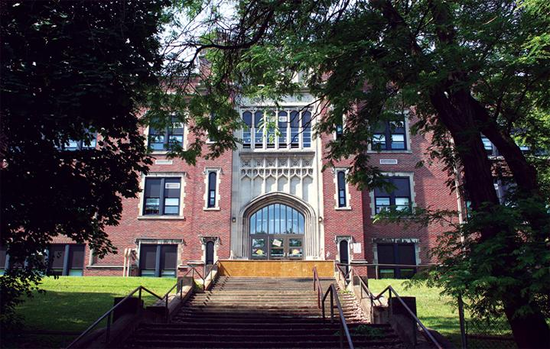

MINIMUM CAPACITY :-

The Minumum intake capacity

of students is between 300-620

children

LIBRARY :-

The Libarary is Available.

CANTEEN:-

The Canteen Facility is Available.

BOARDING :-

No availablility of boarding.

SPORTS :-

There are different categories

sports available.

Girls Volleyball

Boys Volleyball

Football

|  |  |  |
| --- | --- | --- |
| JOHN F HUGHES ELEMENTARY SCHOOL  UTICA - SCHOOL |  |  |
|  |  |  |
| School Detail :- Provide our diverse student population with a high quality education in a safe andorderly school environment. Studentswill engage in lessons that reflect the 21st century learning skillsso they have the knowledge and competencies necessary to be college and career ready. |  |